Expt 7 Q1
Code:
def adding():
a=int(input("Enter a number: "))
b=int(input("Enter a number: "))
sum=a+b
print("The sum is",sum)
adding()
print("Next")
print("")
adding()
print("Next")
print("")
adding()
print("Next")
print("")
adding()
print("Next")
print("")
adding()
print("done")
print("")

Output: 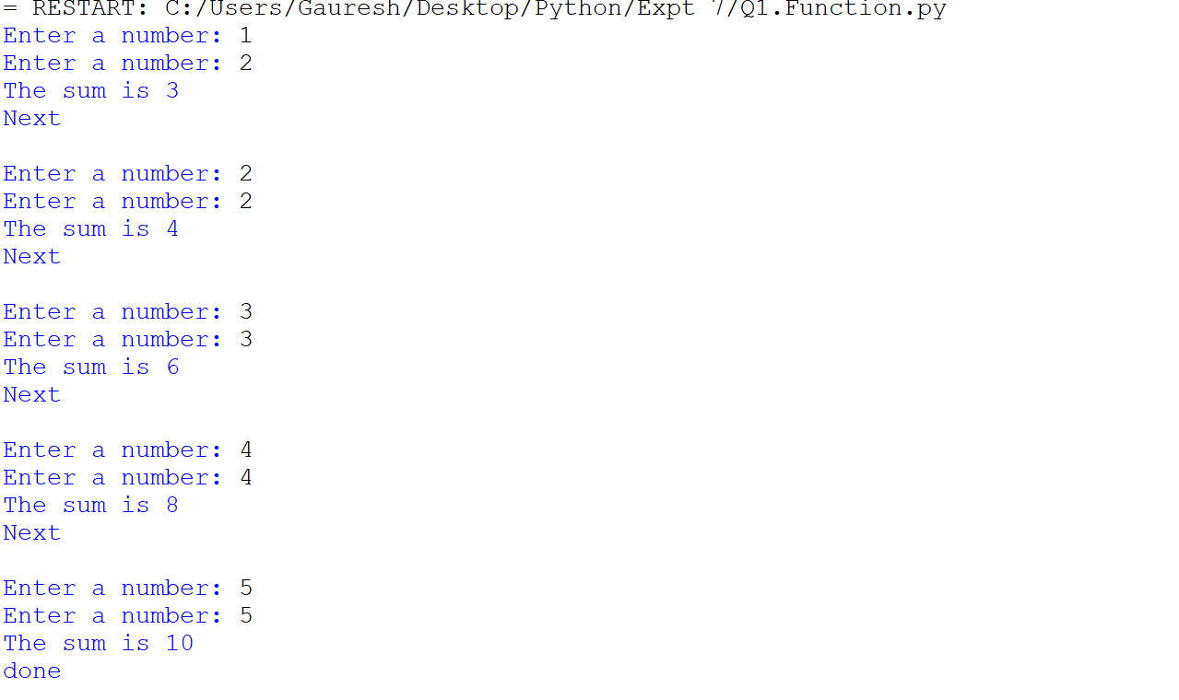
Q2.
Code :
def adding():
a=int(input("Enter a number: "))
b=int(input("Enter a number: "))
sum=a+b
print("The Sum is :",sum)

def multiplication():
a=int(input("Enter a number: "))
b=int(input("Enter a number: "))
mul=a*b
print("The multiplication is :",mul)

def division():
a=int(input("Enter a number: "))
b=int(input("Enter a number: "))
div=a/b
print("The Division is :",div)

def subtraction():
a=int(input("Enter a number: "))
b=int(input("Enter a number: "))
sub=a-b
print("The Subtraction is :",sub)

print("Select user one input \n1.Addition \n2.Multiplication \n3.Division \n4.Subtraction")

user=int(input("Choose number: "))
if user==1:
adding()
elif user==2:
multiplication()
elif user==3:
division()
elif user==4:
subtraction()
else :
print("error")

output:
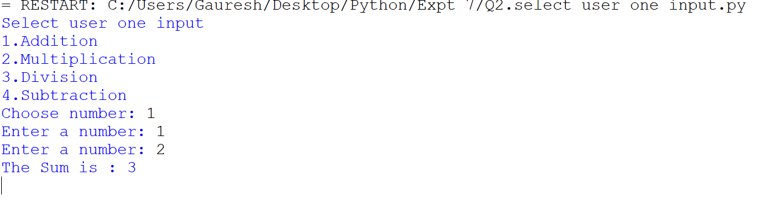

Q3.
Code:
#write a python program that return squre of a number using function
def squre(a):
squres=a*a
return squres
b=squre(5)
print("Squre is :",b)

output:
